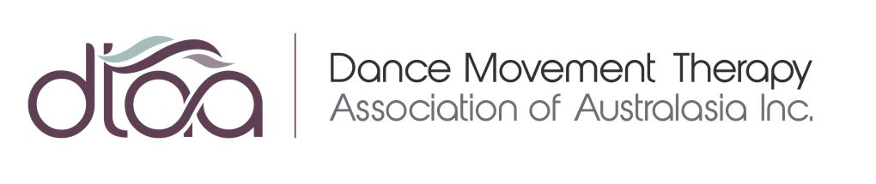

CONTENT SUBMISSION FORM
CURRENT MOVES e-BULLETIN
(Item to be considered for Current Moves edition)
The DTAA’s Current Moves editions are designed to provide information for the Australian dance movement therapy community about upcoming events and opportunities.
Current Moves Editions will be launched every 2 months.
Cost: Free to current DTAA Financial Members
Non Members: $25 per advert per edition published (Refer payment details below)

Date Submitted to DTAA:
Your Details:
DTAA Member: | Yes / No
Name:
Company:
Email:
Website:
Telephone:
Current Moves Edition:
(Refer Edition Dates below)
Date of Event/Time:
Article/Event Title:
Content:
(A brief introduction to your event/article - Please limit content to approx. 150 Words)

Read More Links can be added to take the reader to the full details.
Read More Links:
Image:
(Please insert image here or attach to email. Image resolution must be no lower than 72PPI)
Comments to Designer:

The Current Moves e-Bulletin is published every 2 months. Special Announcement Editions may be sent more frequently. Refer table for approximate Launch Dates/Content Deadlines.
Note: Dates can be subject to change.
Edition Launch Date | Deadline for Content
27 May 2021 | 17 May 2021
28 July 2021 | 18 July 2021
29 September 2021 | 19 September 2021
27 November 2021 | 17 November 2021  (Last Edition for Member Contribution for the Year)
14 December 2021 | Office Use Only  Christmas Closure Notice
27 January 2022 | 17 January 2022
30 March 2022 | 20 March 2022

NON MEMBER PAYMENT DETAILS
Payment Methods:
(Please CIRCLE your payment preference)
EFT: | I have paid EFT to Dance Movement Therapy Association  Bank: WESTPAC  Branch: Middle Brighton  BSB: 033 095 / Account No: 330 037  Amount: $25.00
Your EFT REFERENCE CODE:

(Please ensure you use your SURNAME as the reference code to easily identify your payment)
PAYPAL: | Please issue a PAYPAL INVOICE for $25.00 to the email address listed above.

SUBMIT YOUR FORM
Please email form to:
Donna Parker
DTAA Administration
admin@dtaa.org.au
DTAA reserves the right to decline submissions that do not align with DTAA/DMT policy and pending volume of content requested for insertion.
DTAA takes no responsibility for errors or omissions in Current Moves copy.

