Dance Therapy Association of Australasia (DTAA)
Together with the
‘Creative Arts and Music Therapy Research Unit’ (CAMTRU)
University of Melbourne
Present
Making Connections Suicide Prevention Program (MCSPP)

Observe – Understand – Respect (OUR)

Saturday May 23 and Sunday May 24, 2020, 9am – 5pm

Rooms 810 and 819 (TBC), Ian Potter Southbank Centre, University of Melbourne, 43 Sturt Street, Vic.
CPD: 7 hours/points per day, 3.5 for presentation only.
This two-day presentation and train the trainer program offers a unique approach that utilises the body-mind connection through movement-based, experiential learning. It is developed and designed by Susan Imus, the presenter, and this will be the first time this program, well-known in the USA and in other parts of the world, will be presented in Australia. Susan is the author of Interrupted Rhythms: Dance/movement therapy's contributions to suicide prevention, published in The Routledge International Handbook of Embodied Perspectives in Psychotherapy (Payne, Koch, Tantia & Fuchs, 2019). This presentation and training will be suitable for CAT’s, psychotherapists, counsellors, psychologists, mental health workers and allied health therapists. It uses experiential methods and creative engagement to address social and emotional goals:

The learning objectives for students or clients are to:
- Develop self-awareness and self-management skills to achieve school and life success.
- Use social-awareness and interpersonal skills to establish and maintain positive relationships.
- Develop decision-making skills and responsible behaviours, in personal, school, and community contexts.

Program goals include:
- Enhancing mental wellness.
- Fostering protective factors through life-skills development.
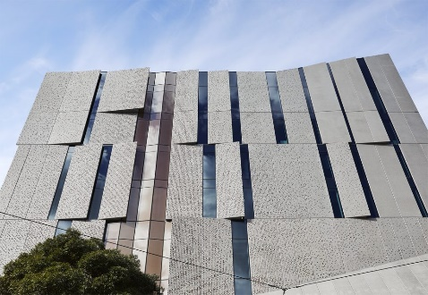
- Learning the suicide prevention steps.
- De-stigmatizing mental health.
- Increasing knowledge about mental illness and suicide prevention.

Ian Potter Southbank Centre, University of Melbourne.

And Program Objectives:
- Participants will identify and apply suicide prevention steps and
- risk factors, warning signs and protective factors of suicide, and
- identify own body signs and those of others.

The presenter - Susan D. Imus
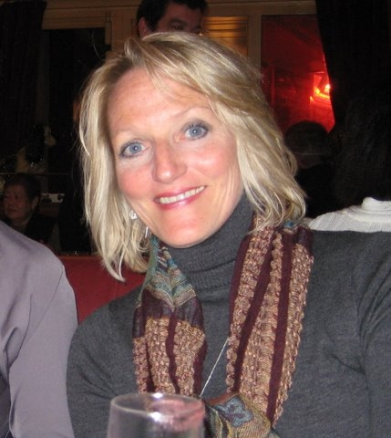
The Dance Movement Therapy Association of Australasia (DTAA) and The Creative Arts and Music Therapy Research Unit of Melbourne University are pleased to welcome Susan, a licensed clinical professional counselor (LCPC), a board-certified dance/movement therapist (BC-DMT), and a graduate Laban certified movement analyst (GL-CMA), who has served as the chair of the Creative Arts Therapy Department at Columbia College, Chicago, since 1998. Following the closure of the department in 2017, Susan shifted to directing the Dance/Movement Therapy & Counseling MA program (in its final year) and the Arts in Health Minor through the Dance Department. She taught for 12 years at the Feinburg School of Medicine at Northwestern Medical Center and is currently in her seventh year working with Rush Medical College’s in their medical humanities program.
Fees
COST | DTAA Member | DTAA member Concession | Non-member | Non-member Concession | UoM CAMTRU student
Full Presentation and Training  (14 hours – Sat & Sun) | $300 | $275 | $395 | $350 | $150
Presentation only  (3.5 hours – Sat am) | $120 | $100 | $150 | $130
Booking can be either for the full two-day training program, or for the Saturday morning presentation only.
For more information, contact Jane Guthrie on info@dtaa.org.au or 0451 924017

REGISTRATION & PAYMENT
To qualify for the Members rate, you must be a financial member of the DTAA. Non-members are welcome to join the DTAA on-line: www.dtaa.org.au

Register on-line through Trybooking (quick and easy): https://www.trybooking.com/BJBGE

REFUND POLICY: Cancellations must be notified to the DTAA by email. Cancellations up to 2 weeks before the event are eligible for refund, minus a $50 cancellation fee. Cancellations made after this date can be refunded in special circumstances, or it may be possible to arrange for another person to attend instead. All refunds will be paid at the conclusion of the event.

