Continuing Professional Development workshop:
Improving our employment possibilities
through evidence-informed practice in dance movement therapy:
what does it mean and how can we do it?
Saturday 26 October 2019, 9.30-5:00 pm, Leela Centre, L2/ 113-115 Oxford St, Darlinghurst NSW
Health and human service professionals are increasingly expected to use evidence to inform their work. This session addresses the topic of evidence and its implications for DM therapists. It focusses on the critical advances made when practice draws from existing information, and the potential for expanded employment opportunities when practice is underpinned by evidence. Participants will also be introduced to techniques in utilising published evidence, from searching for relevant publications to analysis of available information.
The workshop will also involve movement experientials led by DTAA members working with diverse issues and populations through DMT, utilising DMT and related evidence. Finally, participants will be encouraged to consider how they can contribute to the expansion of evidence about DMT, utilising accessible assessment and evaluation tools.
Learning objectives
Participants will:
- advance their understanding of the concept of evidence-informed practice;
- improve their skills in searching for and utilising evidence to inform professional practice;
- enhance their capacity to create evidence by using appropriate assessment and evaluation tools in their practice.
Participants will be eligible for 6 hrs DTAA-accredited CPD.
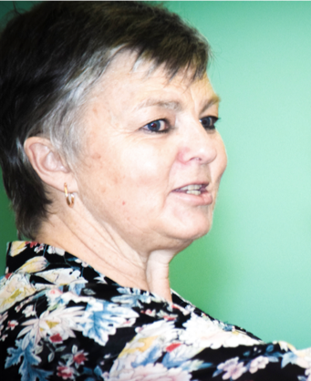
Presenters
Sue Mullane, M. Ed (DMT), Grad. Dip Movement & Dance, B.Ed., DTAA (Prof DMT), is an experienced special educator and DM therapist. She has worked with a focus on disability and trauma with adults and children in a variety of health, community and educational settings in NSW and Victoria.

Dr. Kim Dunphy is a Research Fellow at the Creative Arts and Music Therapies Research Unit, University of Melbourne, where she is exploring her interests in assessment and evaluation of DMT. Kim is also DTAA (Prof DMT) and President.
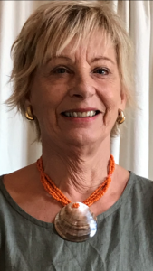
Experiential leaders:
Suzanne Scarrold, Professional Member, New Zealand, Dip (Clin) DMT; MAAT (Clin. ATh.Reg.) ANZACATA; Post Grad Dip Couns & Guidance; PGDipTeaching; BA; Advanced Cert Interactive Drawing Therapy. Suzanne is an arts and DM therapist and member of the DTAA Training & Ed. Committee who recently worked as a senior lecturer in counselling at Manukau Institute of Technology, Auckland
Angela Kastanis, DTAA (Prof. DMT), BA, Dip Ed, Post Grad. Cert TESOL, Neuro-Linguistic Programming, yoga training and a DMT qualification from the IDTIA. Her specialist DMT expertise includes children with physical and intellectual disabilities and elderly citizens in homes.
Clare Etherton, DTAA (Prof. DMT), Cert and Adv Clinical Prac DMT (DTNZ) BA Hons Dance Studies, Grad Dip Teaching, Yoga teacher cert. Clare is a DM therapist, yoga teacher, early childhood and forest school educator.
WHAT TO BRING

- Comfy clothes for movement
- Cushion to sit on
- Laptop, iPad or phone with web browsing and typing capabilities. If oyu don’t have one of these you can bring, we can pair you up with someone who does.
- Writing materials
- Your own lunch. We’ll also send out details of neary lunch options to those registering.

ZOOM ATTENDANCE
This event is also available for attendance by Zoom.

WORKSHOP FEES

DTAA members* | DTAA member concession** | Non-member | Non-member concession**
$140 | $120 | $180 | $160

* To qualify for the Members rate, you must be a financial member of the DTAA. Non-members are welcome to join the DTAA on-line: www.dtaa.org.au.
** Concession is available only to full time students, pensioners and healthcare card holders. You will be reqired to show evidence of your concession status.
For more information, contact Laura Houley: admin@dtaa.org.au or phone 0419 531 218
Or Jane Guthrie: info@dtaa.org.au 0451 924 017.

REGISTRATION & PAYMENT
Our preferred method of registration and payment is to use our easy on-line Trybooking System. This allows us to easily manage, record and communicate with you in relation to your booking Please click on the link below.

https://www.trybooking.com/BFQOR
If you would like to pay via direct debit, please contact Laura for a registration form and payment details, admin@dtaa.org.au
REFUND POLICY
Cancellations must be notified in writing to DTAA by email. Cancellations before 15.10. 2019 are eligible for refund, minus a $50 cancellation fee. Cancellations made after this date cannot be refunded, unless in exceptional circumstances. It may, however, be possible to arrange for another person to attend in your place. All refunds will be paid at the conclusion of the event.

