Continuing Professional Development workshop:

Evidence-informed practice in dance movement therapy:
what does it mean and how can we do it?
Saturday 26 October 2019, 9.30-4.30 pm,
Darlinghurst Community Space, 277 Bourke Street, Darlinghurst NSW.

Health and human service professionals are increasingly expected to use evidence to inform their work. This session addresses the topic of evidence and its implications for DM therapists. It focusses on the critical advances made when practice draws from existing information, and the potential for expanded employment opportunities when practice is underpinned by evidence. Participants will also be introduced to techniques in utilising published evidence, from searching for relevant publications to analysis of available information.
The workshop will also involve movement experientials led by DTAA members working with diverse issues and populations through DMT, utilising DMT and related evidence. Finally, participants will be encouraged to consider how they can contribute to the expansion of evidence about DMT, utilising accessible assessment and evaluation tools.

Learning objectives
Participants will:
- advance their understanding of the concept of evidence-informed practice;
- improve their skills in searching for and utilising evidence to inform professional practice;
- enhance their capacity to create evidence by using appropriate assessment and evaluation tools in their practice.

Presenters:
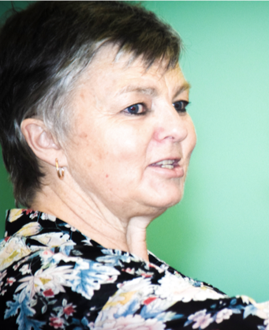
Dr. Kim Dunphy is a Mackenzie Research Fellow at the Creative Arts Therapies Research Unit at the University of Melbourne, Australia, where she is exploring her interests in assessment and evaluation of DMT. She is interested in two main research questions: what difference do we make and how do we know? She publishes widely on these topics, including recent articles in Arts in Psychotherapy and Frontiers in Psychology on developing practical tools for assessment in dance movement therapy. Kim is also a Professional Member of the DTAA; President, Dance Movement Therapy Association of Australasia; Research Committee Convenor, Psychotherapy and Counselling Federation of Australia; and inaugural Convenor of the World Alliance for Dance Movement Therapy.

Experiential presenters: Suzanne Scarrold, New Zealand, other tbc.

