LILJAN ESPENAK’S PSYCHOMOTOR THERAPY SYSTEM
Including the renowned diagnostic tests and exciting mask work
Presented by Nana Koch - the ‘Embodied Protégé’
Sat 12th and Sun 13th January 2019, 9.30am – 5.00pm
Edinburgh Gardens Community Room, Alfred Crescent, North Fitzroy, Melbourne, 3068
CPD: 12 hours or 6 hours per day
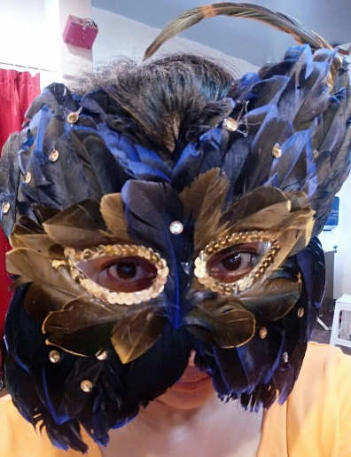
The Dance Movement Therapy Association of Australasia (DTAA) is excited to welcome Nana Koch to Melbourne. Nana, as a student, was mentored by Liljan Espenak, a pioneer of dance movement therapy in the USA. Nana is now a leader in her field in carrying Espenak’s legacies forward. Join us for this very special event, which is the first time this pioneer’s theories and philosophies, that were strongly influenced by Wigman, Adler and Lowen, have been presented in Australia in this workshop capacity. Of particular interest: Liljan was an early DMT visitor to Australia in the late 1980’s, when she presented a paper on her work at an international conference.

In this workshop, Liljan Espenak's (1905–1988) system of psychomotor therapy focuses on the ways in which Liljan used expressive dance and diagnostic movement tools to facilitate integration, the ideal body and feelings of well-being. Adler and Lowen’s influence on Espenak's work is discussed, along with concepts inherent in psychomotor therapy and its areas of application. By acquainting participants with Espenak's concepts of diagnosis, restructuring, and integration, they will learn how she used particular exercises to help patients express "the four emotions," develop muscle-memory, and experience catharsis, all leading to behavioral change. Liljan also used masks in treatment to foster in her patients the emotional release from their unconscious, and this work will be presented during the two-day workshop. It is not to be missed!
Our presenter – the ‘Embodied Protégé’
Nana Koch, Ed.D, BC-DMT, LCAT, NCC, LPC, CMA, is the former coordinator of the Hunter College Dance/Movement Therapy Masters Program. Additionally, she is the former Chair of the ADTA Sub-Committee for Approval of Alternate Route Courses, former chair of ADTA’s Credentials Committee and member of the Approval Committee. She is also a board-certified dance movement therapist, licensed creative arts therapist as well as educator. Nana studied with Liljan Espenak in one of the earliest courses Espenak offered at Flower and Fifth Avenue Hospital/Mental Retardation Clinic. Nana has taught dance/movement training courses based on

Liljan's work at Kinections in Rochester and in courses in Costa Rica, Mainland China, Hong Kong and India. She also specialises in teaching courses on group process in dance/movement therapy. Nana is currently on sabbatical from Long Island University-Post, where she is an Associate Professor and newly retired Chairperson of the Department of Health, Physical Education and Movement Science.

This two-day workshop will be suitable for dance movement therapists, psychotherapists, psychologists and creative arts therapists. We strongly encourage applicants take advantage of the 2 days of teaching, but if absolutely not possible, the costs of one day are on Trybooking.

WORKSHOP FEES
COST | DTAA member | DTAA member concession | Non-member | Non-member concession
Two Days | $270 | $240 | $340 | $305
To qualify for the Members rate, you must be a financial member of the DTAA. Non-members are welcome to join the DTAA on-line: www.dtaa.org.au. The cost is $65 for general and associate members, concession $55. Concession is available to full time students, pensioners and healthcare card holders.
For more information, contact Jane Guthrie on info@dtaa.org.au or 0451 924017.

REGISTRATION & PAYMENT
The quickest and easiest way to register is on-line through the Trybooking System. There is no need to fill in any other details.
Click on https://www.trybooking.com/ZIUN

OTHER PAYMENT METHODS
EFT, cheque - complete and submit this form. Email to admin@dtaa.org.au or mail the form to: DTAA, PO Box 641, Carlton South, Melbourne 3053
First name:_______________ Family name:__________________________

Phone: ________________________________

Email: _________________________________
Payment Method: EFT □ Date paid: _____________
EFT to DTAA BSB: 033 095 (Westpac) Account: 330037
Cheque □ Please send cheque to details above.

REFUND POLICY:
Please note the DTAA is unable to fully refund registrations. Cancelations made more than 5 days before the event via admin@dtaa.org.au are eligible for a 50% refund, however cancellations made after this, with the exception of extenuating circumstances, cannot be refunded. Depending on the circumstances transfer to another name may be allowed or a credit towards a future DTAA event (excluding conferences).

