Body as Voice:
Restorative Movement Psychotherapy
A training with international trauma expert Amber Gray

Part 3
Friday 14th - Monday 17th December 2018
9:45am – 5:15pm
Emily Baker Centre, Edinburgh Gardens, Melbourne
Alfred Crescent, North Fitzroy, VIC 3068

The DTAA is pleased to welcome Amber Gray back to Australia for Part 3 of Body as Voice. Amber offers unique training in Restorative Movement Psychotherapy for survivors of trauma in a body, movement, and rhythm based framework.

Part 3 of Body as Voice will build on and continue work with the dyadic therapeutic relationship – integrating working with families, groups and communities. This group-focused module emphasises integration, wholism and restoration of a sense of belonging. Polyvagal informed DMT is elaborated, and based on the group composition, working with everything from group therapy to large-scale disaster and complex humanitarian emergency responses are optional topics. This module serves as an integration and closure for the cohort.

Body as Voice Part 1 and 2 are prerequisites for attending Part 3. Please contact info@dtaa.org.au
if you think you may qualify for admission based on other experience or for any further information.

Of note, Part 1 and 2 are approved for ADTA Alternate Route (Graduate Level) Training, and Part 3 is in process.
This workshop counts as 24 hours of category A CPD for DTAA members.

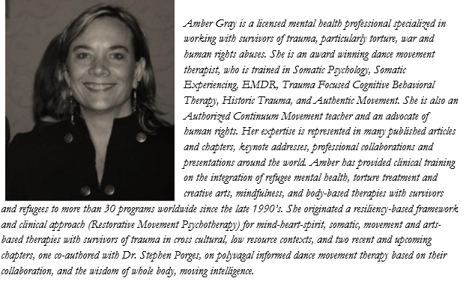

Costs:
Member | Member concession | Non-member | Non-member concession
810.00 | 760.00 | 920.00 | 840.00

The preferred method of payment is to use the quick and easy Trybooking system. Just click on the following link: https://www.trybooking.com/ZREB

If you choose the DTAA member option, you must be a current financial member.

Or complete the form below and return to: DTAA, PO Box 641, Carlton South, Melbourne 3053 or email to info@dtaa.org.au Enquiries to 0451924017
--------------------------------------------------------------------------------------------------------------
REGISTRATION FORM / INVOICE DTAA, ABN: 26 323 204 775

For EFT please complete this form, save as a Word document and email to admin@dtaa.org.au.

First name: ……………… Family name:
Phone: …………………….. Email:
Amount Paid: $
Date paid: …………. (DTAA, Westpac, Middle Brighton branch, BSB: 033 095, A/c: 330037)
* You will be asked to provide evidence of your concession status.

