Writing successful grant proposals
Learn skills of writing successful grants
in a workshop designed specifically for
dance movement therapists and other creative arts therapists

Presented by Dr Kim Dunphy, Research Fellow, University of Melbourne.
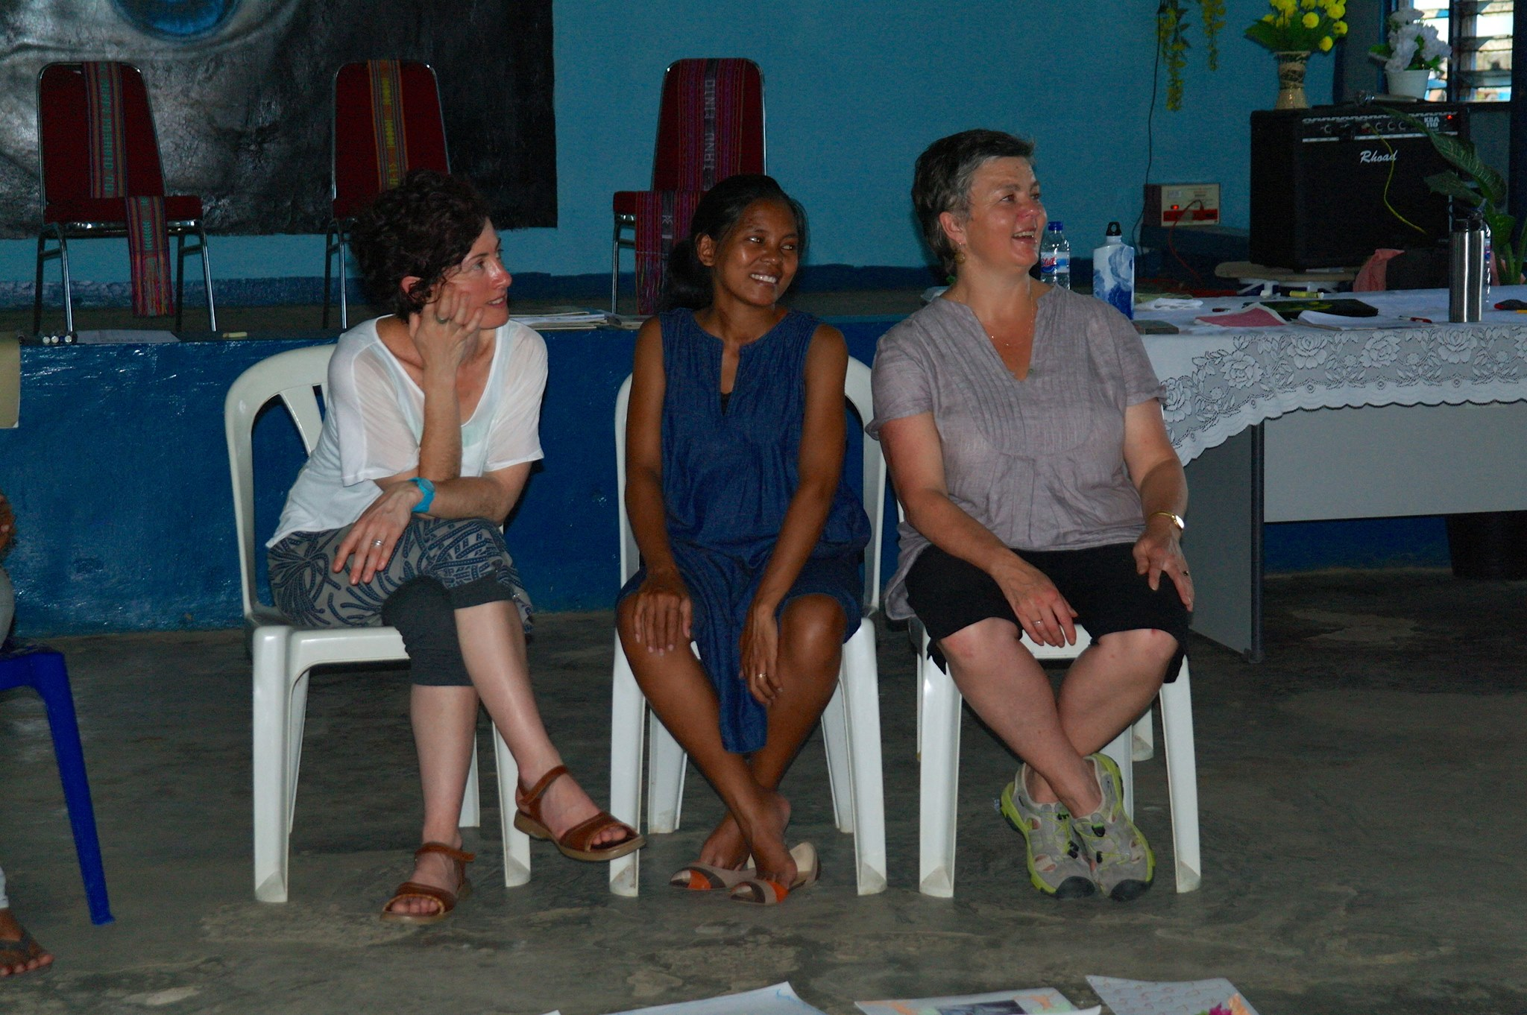
While dance movement and other creative arts therapists are highly skilled in considering clients’ needs and developing therapeutic programs to address these needs, they often struggle with finding ways to fund their work. This workshop helps address that problem by offering a practical and hands-on session in seeking out and writing successful grant applications.

The workshop offers participants the opportunity to develop a successful grant proposal. It includes skill development in finding a relevant grant opportunity, sharpening responses to selection criteria, providing relevant background and articulating the benefits of the proposed project for stakeholders from funders, to participants and the wider profession.
Kim with Marita Jacobsson leading a creative arts therapy program in Timor-Leste that was supported by HEMF research grant.

Participants should come with a specific project or grant round in mind, and will spend the day working specifically on that task. They can expect to complete the workshop with a proposal well-developed for submission!

The Hanny Exiner Memorial Foundation, offering grants for DMT research, close on August 27th. The timing of this workshop is perfect for those interested in making an application. This workshop is highly recommended for those wishing to make a submission.

Date and time: Saturday July 14th, 10am – 5pm; with lunch break 12.30-1.15pm
Venue: Fitzroy Library, Meeting room 1, 128 Moor St, Fitzroy Victoria or by Zoom from anywhere.
Materials required: BYO laptop computer or other writing materials
Included: tea, coffee and morning and afternoon snacks. BYO lunch.

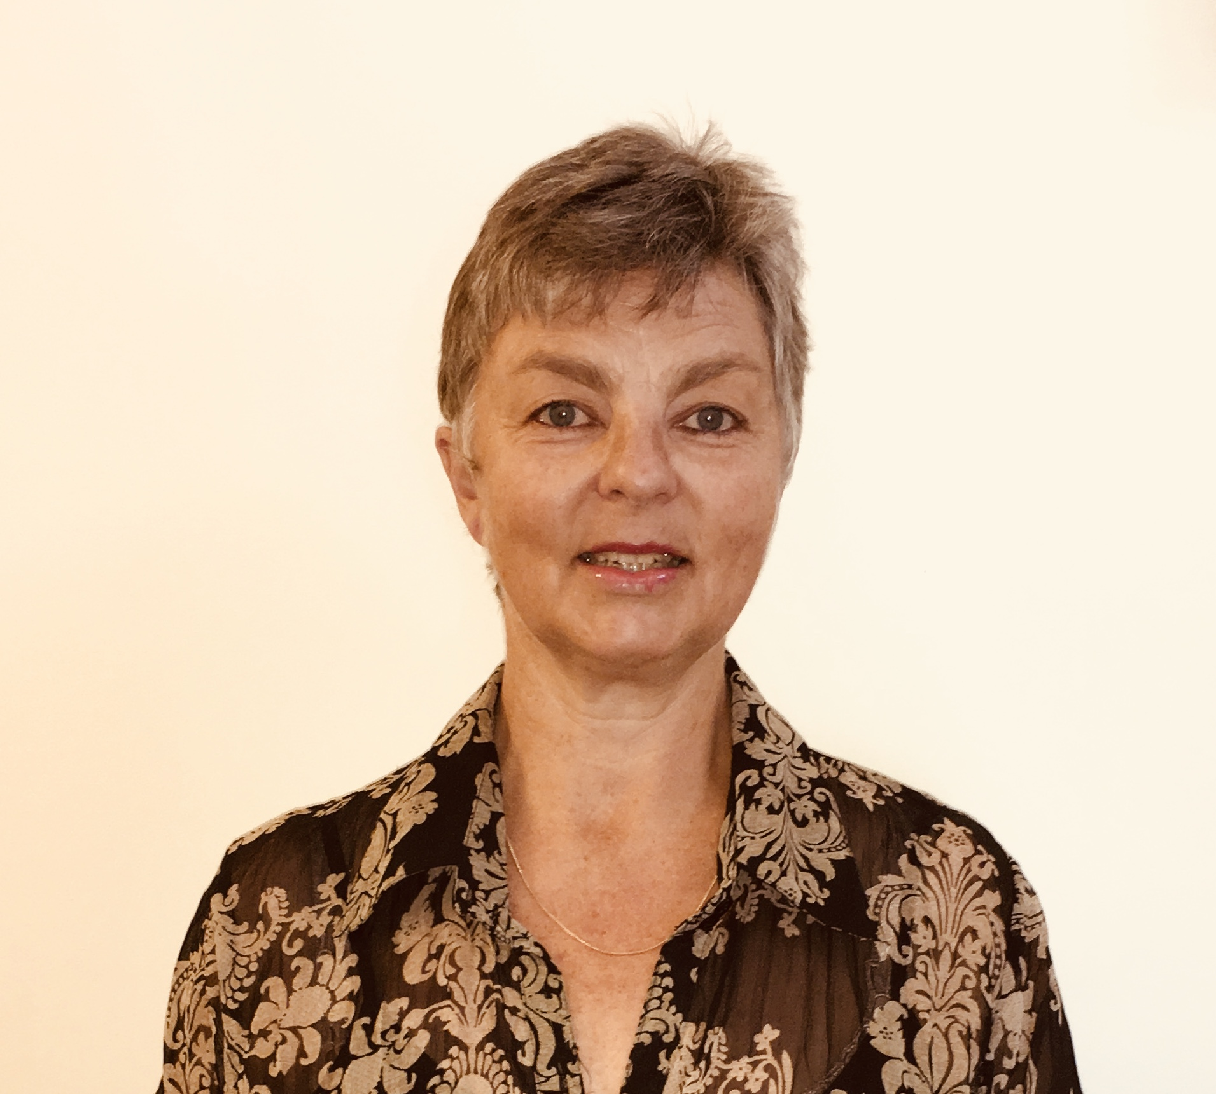
Presenter Kim Dunphy has written successful grant proposals for hundreds of thousands of dollars to funding bodies in Australia and other countries, including local, state and federal governments, philanthropic organisations, private funders, universities, professional service organisations (including PACFA and UNESCO), and others. All of these have been for arts projects or research and many for dance movement therapy. She has also made successful proposals to HEMF and supported several other DM therapists to write them also, and is the first Australian (with Alex Jordan) ever to have received a grant from the US-based Marion Chace Foundation. Kim’s successful application to the University of Melbourne for a Mackenzie Post-Doctoral Fellowship enabled her to become Australasia’s first salaried DMT researcher.

REGISTRATION INFORMATION

WORKSHOP FEES
COST | DTAA members | DTAA member concession* | Non-member | Non-member concession*
 | $140 | $120 | $170 | $150

You are welcome to join the DTAA on-line. Cost $65 for General membership and $55 for concession. Concession is available only to full time students, pensioners and health care card holders. For further membership level details or to join visit http://dtaa.org.au/dtaas-membership-levels/membership/

For more information, contact Jane Guthrie or Laura Houley via admin@dtaa.org.au or phone 0419531218. Limited bursaries are available to those in financial need contact Jennifer Helmich - jennifer.helmich1@bigpond.com

To register: Use our easy on-line Trybooking System link to make your payment.
Click on https://www.trybooking.com/VUIQ or https://www.trybooking.com/382840

Or an EFT payment can be made into our account. See the details below. A registration form is not necessary if you are using Trybooking, only if you are using other methods of payment.
--------------------------------------------------------------------------------------------------------------
EVENT REGISTRATION FORM / INVOICE DTAA ABN: 26 323 204 775

Full name:

Phone:

E-mail:

Payment Method: EFT □ Date paid: …………………...

EFT to DTAA, Westpac, Middle Brighton branch BSB: 033 095 Account: 330037

Cheque □ Visa □ Mastercard □

Cardholder’s Name: ………………………………………

Signature:……………………………………

Card number: …………………………………………………………… Expiry date: ………………

TOTAL PAYMENT: $ ………………

