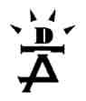
The Dance-Movement Therapy Association of Australia
and the Hanny Exiner Memorial Foundation
Third Australian Dance-Movement Therapy Conference

Big Night Out
‘Weaving The Threads’
conference dinner

Mamma Vittoria’s restaurant
343 Smith St, Collingwood (near corner Johnson St)
Saturday November 10, from 7 pm

Enjoy a delicious three course dinner and drinks,
and a great night of entertainment and networking.
Meet other conference delegates and presenters in an informal setting.

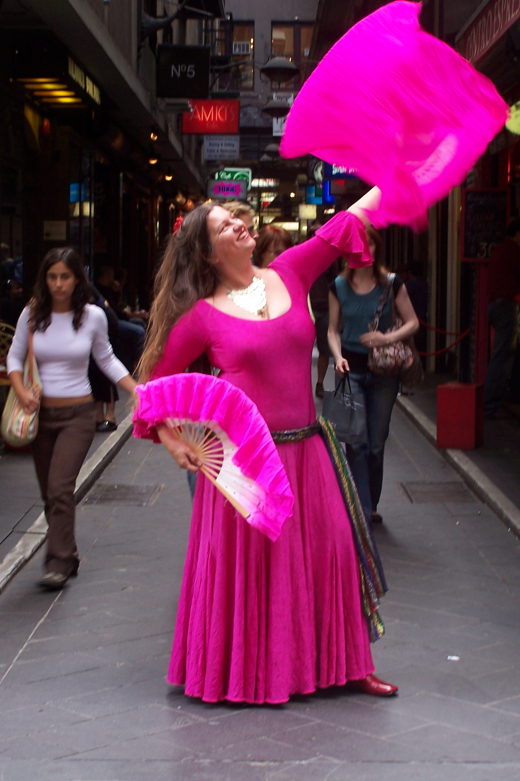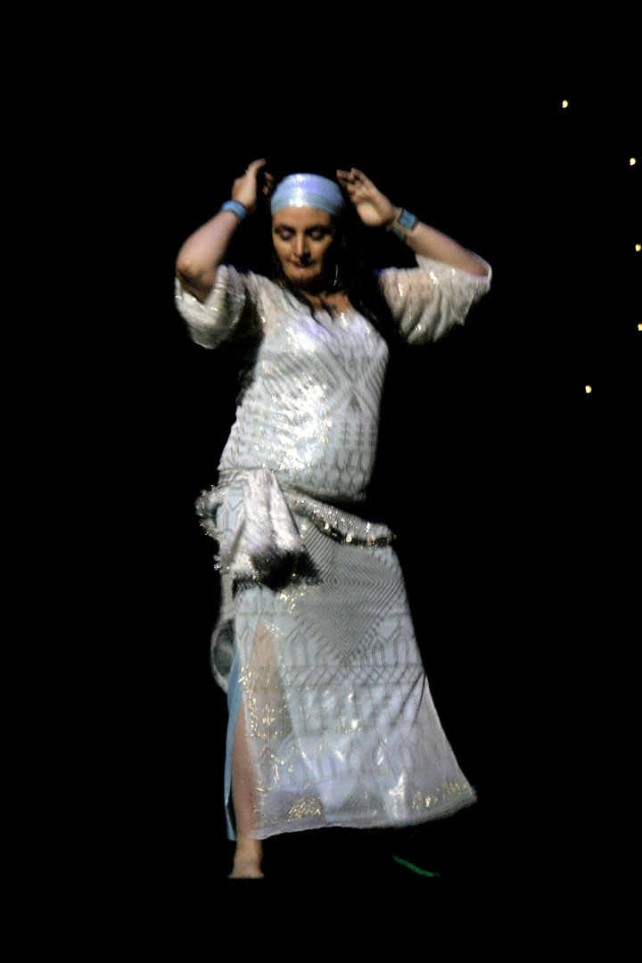

Enjoy barefoot flamenco with Marina Bistrin
Hilal, contemporary Egyptian dance, with Natalie Poole
and Egyptian Raqs al Baladi, with Maria Sangiorgi

Dinner menu: Homestyle Italian cooking
Starters: wood fired roasted focaccia bread and antipasto platters
Secondi: a banquet of Mamma Vittoria and family’s signature homemade pastas and sauces and crisp seasonal salad
Terso: Dessert and tea/coffee

Marina Bistrin teaches Middle-Eastern dance, Barefoot Flamenco, Silk-Road dance and various workshops involving improvisation and cross-cultural dance play. Her aim is to encourage people to move and express themselves freely and safely in dance and movement. She also enjoys performing, especially in improvised fusions of different dance forms, with many types of music. www.dance-explorer.com

Natalie Poole is one of three associate teachers of Egyptian Hilal dance in Australia. She is also an art, media and English teacher in high schools, has taught art in primary schools and is currently studying the journey of birth with local identity Rhea Dempsey. Pregnancy, birth and the post natal period have become Natalie’s areas of her focus in dance therapy.

Maria Sangiorgi’s dance is Egyptian Baladi, dance of my country or of the people. Maria describes her work: ‘I have been teaching and performing Egyptian Dance affectionately known as Raqs Sharqi for 18 years. I love to bring a deep sense of body awareness and understanding of what is actually happening from the inside out so that my students are free to move in an authentic way. I am also a member of Yalla, Middle Eastern Music and dance group. http://www.dancingisis.com

PLEASE CUT AND RETURN THIS SECTION (BELOW). KEEP THE TOP HALF FOR YOUR REFERENCE

DINNER REGISTRATION FORM/ TAX INVOICE ABN: 26 323 204 775
(Please complete this form for people who are attending only the conference dinner)

First name: Family name:
Job title: Organisation:

Address:

Phone: E-mail:

PAYMENT METHODS
Full payment must accompany your dinner registration.

Top of Form
Payment Method: Cheque □ Visa □ Mastercard □ EFT □ Date paid:…………………...
or EFT to ‘DTAA Resources’ Westpac, Hampton branch BSB: 033 055 Account: 2029 89

Cardholder’s Name: ……………………………………… Signature:……………………………………

Card number: …………………………………………………………… Expiry date: ………………

Conference dinner …….. tickets @ $44 early bird until Sept 28/ …………….. tickets @ $55

TOTAL PAYMENT: $

Please complete this form and return by post to: DTAA, PO Box 469, Brighton 3186, Victoria,
or save as Word document and email to conference@dtaa.org

ENQUIRIES: Annette Dunphy on conference@dtaa.org or (+61 3) 9530 5206
Form also available from: www.dtaa.org/conference/registration.htm

