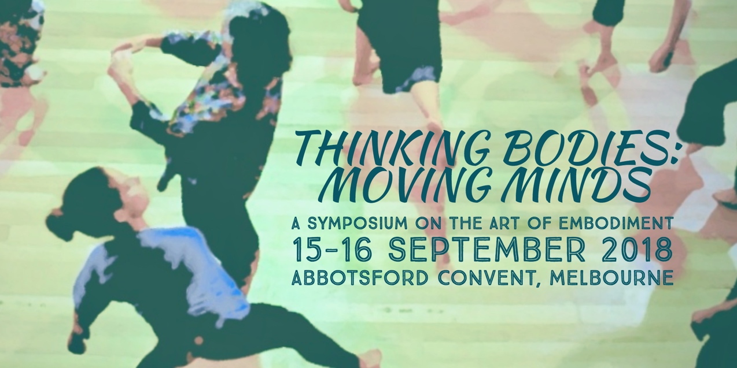

What defines the art of embodiment? In somatics and dance movement therapy practices, embodiment is a core philosophical assumption, one that is so embedded in what we do that we may find it challenging to articulate or identify what we mean by the term. This symposium will offer a wide range of opportunities to investigate and reflect on meanings and experiences of embodiment, in order to share, deepen and enrich our somatic practices.

We invite you to be part of this inaugural Australian somatics symposium, joining leaders from the fields of somatics, dance and dance movement therapy, all of whom share a common interest in embodied practices. The historic Abbotsford Convent provides the perfect venue for this rich program of deeply experiential movement workshops, thoughtful presentations and discussion, reflection and professional development.

Registration will open from 8:30am, and the event will conclude at 5:30pm on both days.
Remember to book early to secure your place!

Closer to the event an up-to-date list of presenters and session details will be available at www.dtaa.org.au/events.

Symposium organizers:
Jane Guthrie, M. Ed (Advanced Studies in Movement and Dance), Grad Dip Movement and Dance, Dance Therapy Certificate, B. App. Sc. Phty, CMA, DTAA (Prof. DMT) and Secretary DTAA.
Heather Hill, PhD, M.Ed., B.A., Grad. Dip. Movement and Dance, Grad. Cert. Dance Therapy, DTAA (Prof.DMT)
Kim Sargent-Wishart, PhD, Certified Body-Mind Centering® Practitioner, Registered Somatic Movement Educator (ISMETA), BA (hons) Dance.

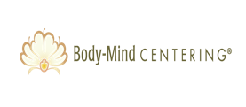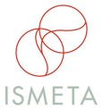

THINKING BODIES: MOVING MINDS SYMPOSIUM FEES

 | DTAA, BMCA, ISMETA Members  & Concession | FULL FEE (Non-members)
One day Symposium | $135 | $170
Two-day Symposium | $250 | $320

For more information on registration, contact Jane Guthrie or Laura Houley via admin@dtaa.org.au or phone 0451924017 or 03 95924017.

TO REGISTER

Register online with a credit card at: www.trybooking.com/VUFU

OR
Fill out the form below for EFT, cheque or credit card payments.
--------------------------------------------------------------------------------------------------------------

EVENT REGISTRATION FORM / INVOICE
For EFT cheque or credit card payments only, please complete this form and email to admin@dtaa.org.au or mail the form to:
DTAA, PO Box 641, Carlton South, Melbourne 3053

First name:_______________ Family name:__________________________

Phone: ________________________________

Email: _________________________________

Payment Method: EFT □ Date paid: _____________

EFT to DTAA BSB: 033 095 (Westpac) Account: 330037

Cheque □ Visa □ Mastercard □

Cardholder’s Name: ______________________________________

Signature: ______________________________________________

Card number: ___________________________________________

Expiry date: _______________ Amount Paid: $______________

The Symposium is under the auspices of the Dance Therapy Association of Australasia (DTAA), with support from the Body-Mind Centering® Association and ISMETA (The International Somatic Movement Education and Therapy Association).

Body-Mind Centering® and are registered service marks of Bonnie Bainbridge Cohen, used with permission.

