Body as Voice:
Restorative Movement Psychotherapy
A Training with international trauma expert Amber Gray

PART 2
Melbourne April 20th – 23rd 2018!

Friday 20th & Satruday 21st, Loughnan Hall, 57-65 Coppin Street, Richmond

Sunday 22nd & Monday 23rd, Edinburgh Gardens, Alfred Crescent, Fitzroy North

Please note you must have competed PART 1 to be eligible to participate in PART 2 of this valuable training.

Amber’s 3 part training is based on her 20 years experience as a Dance Movement Therapist and Somatic Psychotherapist specializing in interpersonal trauma, including torture treatment, refugee mental health, ritual abuse, childhood trauma and human rights violations, in cross cultural contexts. Of note, Part 1 and 2 are currently approved for ADTA Alternate Route (Graduate Level) Training, and Part 3 is in process.
Part 2, “Body as Voice: Body Wisdom”, will emphasize embodiment of resources with somatic and movement-based processing of trauma narratives, to support connection and meaning making and Part 3 “Body as Voice: The Collective Body”, builds on work with the dyadic therapeutic relationship, integrating working with families, groups and communities. It emphasizes integration, wholism and restoration of a sense of belonging.

More about Amber:
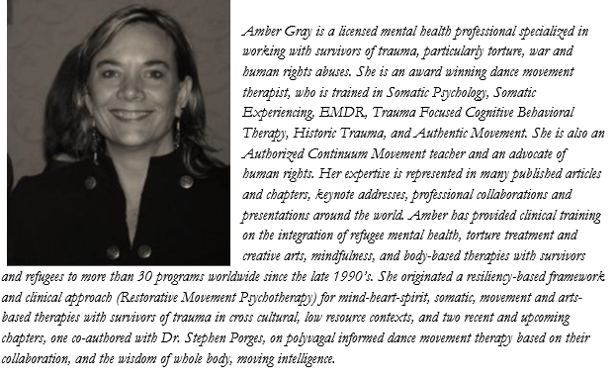

Costs:
Member | Member concession | Non-member | Nonmember concession
760.00 | 700.00 | 920.00 | 840.00

Contact Jane Guthrie on admin@dtaa.org.au

If you choose the DTAA member option, you must be a current financial member.

To enroll purchase tickets on-line through Trybooking by clicking on these links: https://www.trybooking.com/USTR or https://www.trybooking.com/364199

Or complete this form below and return to: DTAA, PO Box 641, Carlton South, Melbourne 3053 or email to admin@dtaa.org.au 0419 531 218

------------------------------------------------------------------------------------------------------------
EVENT REGISTRATION FORM Part 1/ INVOICE DTAA ABN: 26 323 204 775

First name: Family name:

Phone: E-mail:

EFT to DTAA, Westpac, Middle Brighton branch
BSB: 033 095 Account: 330037

Cheque □ Visa □ Mastercard □

Cardholder’s Name: ………………………………………Signature:……………………………………

Card number: …………………………………………………………Expiry date: ………………

TOTAL PAYMENT: $ ………………

Please contact admin@dtaa.org.au ASAP should you wish to participate in PART 2 of Amber’s training.

