For dancers, dance movement therapists, and anyone involved in movement, dance events, or movement rituals

Don’t miss this exciting event

Internationally recognized choreographer, Dance Movement Therapist, founder Global Water Dances

Marylee Hardenbergh in Melbourne, Australia
January 20th 21st 2018

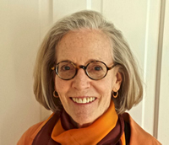
Founding member/original Artistic Director Global Water Dances and Artistic Director Global Site Performances, Marylee is known for her the outdoor site-specific choreographies that she has organized for over the last 30 years.
She is the receiver of numerous awards and grants including fellowships for choreography from the National Endowment of the Arts in the USA and the Soros Foundation. She has led many movement choirs, and also has practiced as a dance movement therapist for over 40 years. She trained under Irmgard Bartenieff and Penny Lewis Bernstein; loves to use Space Harmony in her work, and brings in a therapeutic sensitivity to all of her choreography. She will conduct a two-day workshop in Melbourne:

Dancing in Space, Dancing in Community
Community-based Dance, Movement Choirs & Space Harmony
January 20th 21st 2018 9.30am- 5pm (12 hours CPD)
1 St. Heliers Street, Rosina Auditorium - Abbotsford Convent

Join us for a workshop in learning how to direct a community-based performance or Movement Choir. Learn about the overlapping concepts of dance therapy and site-specific dance which are available to groups and individuals in all situations.
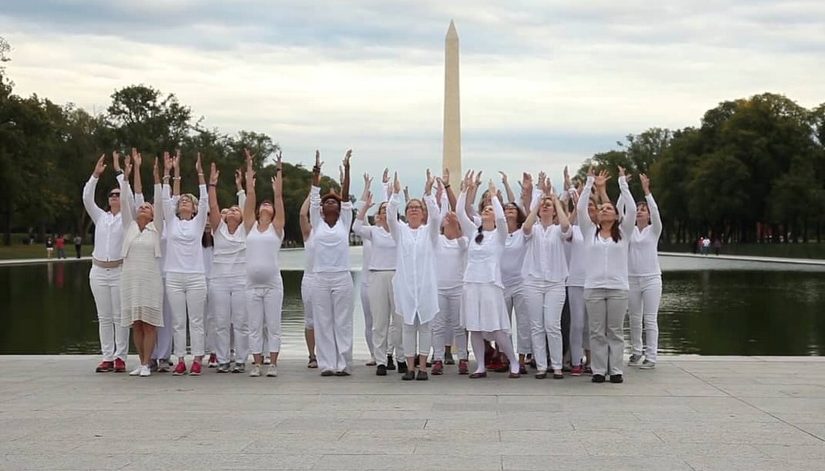
Washington Monument and Reflecting Pool from the Lincoln Memorial steps (2016)
Community-based dance performances have a strange and wonderful way of creating rippling, healing effects on the community. Therapeutic aspects include such concepts as:
- inclusivity
- shared purpose
- a reconnection to something larger
- seeing oneself in a new way

Hardenbergh uses ‘Space Harmony’ in the development of large or smaller groups for healing dances/community events/site-specific performances. She will teach a simple exercise that promotes psychological attachment to, and embodiment of, the Dimensional Cross. This and other forms are used as creative tools for all dancers and movers, and offer an easy use of structure for both teachers and therapists.

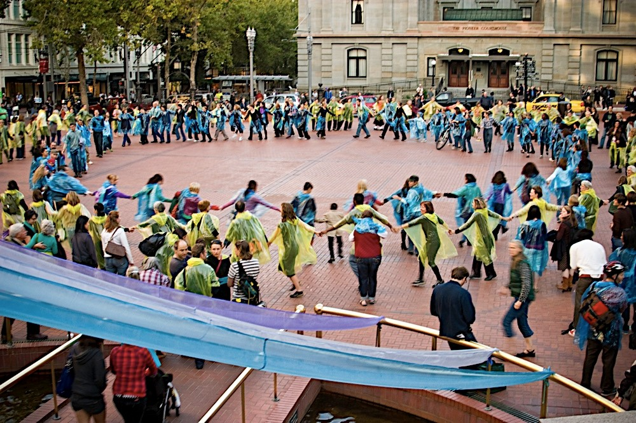
‘Rain or shine’ ADTA conference, Portland Oregon (2016)

Hardenbergh’s teacher, Irmgard Bartenieff, taught that we can all learn to “lean” on spatial tensions; space can also help us strengthen our boundaries and deepen our sense of confidence.
The workshops will take place in the grounds of the historic Abbotsford Convent in Melbourne.
The skills learnt and development of the workshop over the weekend, will all lead to the creation of a site-specific event, which will take place come rain or shine. Dancers and therapists are welcome to join in with the performance aspect which will be late on the Sunday afternoon. Anyone and everyone will be welcome to join in. The two day workshop is recommended for anyone involved in community dance for pleasure, recreation and / or, for general wellbeing.

Global Site Performance is the creation of Marylee Hardenbergh. Her goal is to use dance to transform the environment so that people experience it with renewed eyes and heart. She believes that the power of dance -- with its moving colors and harmonious rhythms -- deepens the audience's sense of place and how we humans fit into the landscape.
http://globalsiteperformance.org

Closer to the time of the event look out for instructions about what colour to wear, or what to bring with you if you are coming only for the performance. Also, the performance time will be posted shortly and will be late on Sunday afternoon. See: www.dtaa.org.au

WORKSHOP FEES
COST | DTAA and Ausdance members* | DTAA and Ausdance member conc.* | Non-member | Non-member concession*
For two-day workshops | $290 | $260 | $370 | $320

* Please note: Ausdance members are invited to book in at DTAA Member rates. Non-members are welcome to join on-line: www.dtaa.org.au.

If you are coming for the performance only, we suggest a small donation towards Abbotsford Convent’s ongoing renovation program.

For more information, contact Jane Guthrie or Meagan Otu via admin@dtaa.org.au or phone 0451924017, or 03 95924017.

TO REGISTER
Use our easy on-line Trybooking System link to make your payment.
Click on https://www.trybooking.com/SXNW or https://www.trybooking.com/332276
OR
Make an EFT into our account or pay by credit card (see below).
A registration form is only required if you are using another method of payment.
--------------------------------------------------------------------------------------------------------------

EVENT REGISTRATION FORM / INVOICE DTAA ABN: 26 323 204 775

For EFT cheque or credit card payments only, please complete this form, save as a Word document and email to admin@dtaa.org.au or mail the form to: DTAA, PO Box 641, Carlton South, Melbourne 3053.

First name: Family name:
Phone: Email:

Payment Method: EFT □ Date paid: …………………...

EFT to DTAA, Westpac, Middle Brighton branch BSB: 033 095 Account: 330037

Cheque □ Visa □ Mastercard □

Cardholder’s Name: ……………………………………… Signature: …………………………………

Card number: …………………………………………………………… Expiry date: ………………

TOTAL PAYMENT: $ ………………

