Writing successful Grant Proposals
Learn the skill of writing a successful grant proposal in a workshop
designed specifically for dance movement therapists and other creative arts therapists

Presented by Dr Kim Dunphy

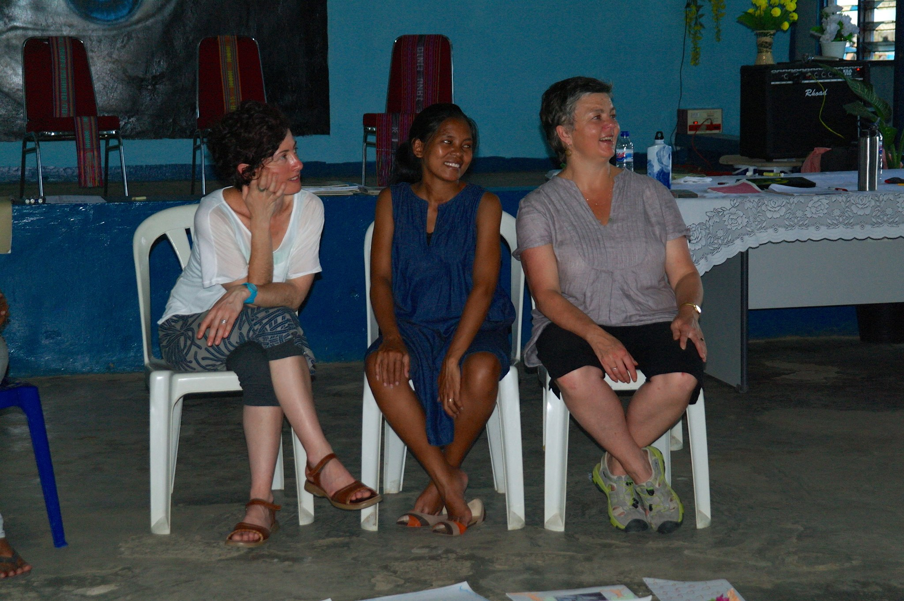
While dance movement and other creative arts therapists are highly skilled in considering clients’ needs and developing therapeutic programs to address these needs, they often struggle with finding ways to fund their work. This workshop helps address that problem by offering a practical and hands-on session in seeking out and writing successful grant applications.

The workshop offers participants the opportunity to develop a successful grant proposal. It includes skill development in finding a relevant grant opportunity, sharpening responses to selection criteria, providing relevant background and articulating the benefits of the proposed project for stakeholders from funders, to participants and the wider
Kim with Marita Jacobsson leading a creative arts therapy program in Timor-Leste that was a supported by HEMF research grant.
profession.

Participants should come with a specific project or grant round in mind, and will spend the day working specifically on that task. They can expect to complete the workshop with a proposal well-developed for submission!

The Hanny Exiner Memorial Foundation, grants for this year, offering grants for DMT research, close on July 17. The timing of this workshop is perfect for those interested in making an application.

Date and time: Saturday May 27, 9.30-4.30; with lunch break 12.30-1.15
Venue: Fitzroy Library, Meeting room 1, 128 Moor St, Fitzroy VIC 3065
Materials required: BYO laptop computer or other writing materials
Included: tea, coffee and morning and afternoon snacks.
BYO lunch.

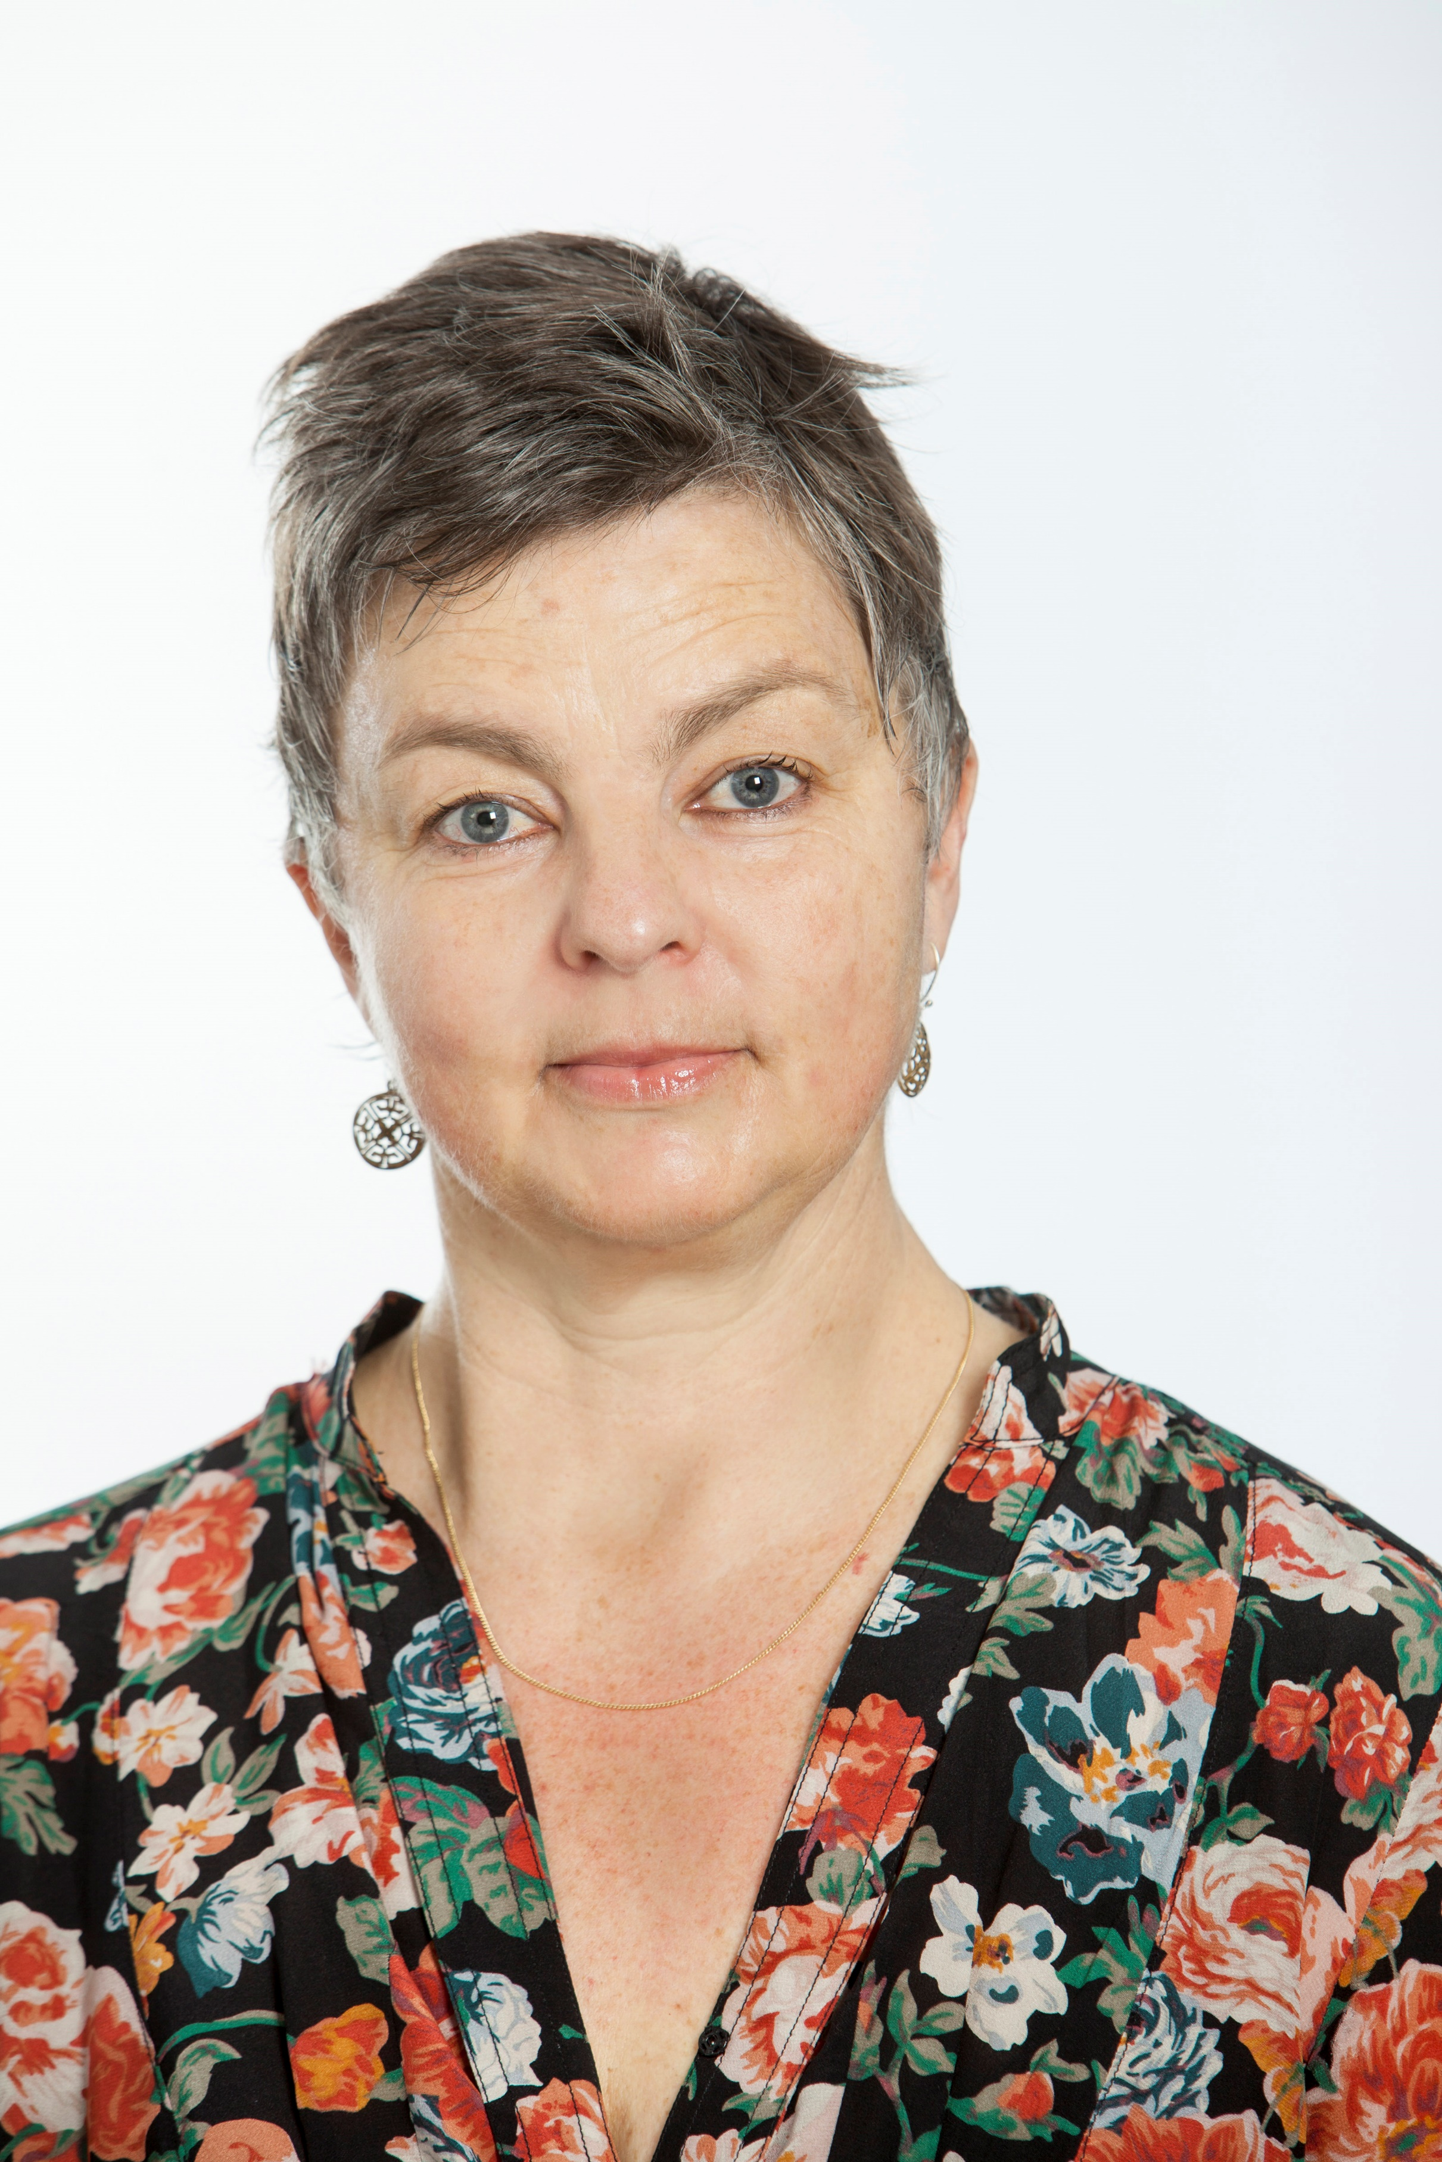
Kim Dunphy has written successful grant proposals for hundreds of thousands of dollars to funding bodies in Australia and other countries, including local, state and federal governments, philanthropic organisations, private funders, universities, professional service organisations (including PACFA and UNESCO), and others. All of these have been for arts projects or research and many for dance movement therapy. She has also made successful proposals to HEMF and supported several other DM therapists to write them also. Kim’s most recent application was for a Mackenzie Post-Doctoral Fellowship at the University of Melbourne, where she is now Australasia’s first salaried DMT researcher.

REGISTRATION INFORMATION

WORKSHOP FEES
COST | DTAA members | DTAA member concession* | Non-member | Non-member concession*
 | $140 | $120 | $170 | $150

You are welcome to join the DTAA on-line: www.dtaa.org.au Cost $60 for general and associate members, concession $50. Concession is available only to full time students, pensioners and health care card holders. For more information, contact Jane Guthrie or Tess Hens via admin@dtaa.org.au Or phone 0419531218

To register: Use our easy on-line Trybooking System link to make your payment.
Click on https://www.trybooking.com/PHUQ or https://www.trybooking.com/268908

Or an EFT payment can be made into our account. See the details below, or use any other method of payment, A registration form is not necessary if you are using Trybooking, only if you are using another methods of payment.
--------------------------------------------------------------------------------------------------------------
EVENT REGISTRATION FORM / INVOICE DTAA ABN: 26 323 204 775

First name: Family name:
Phone: E-mail:

Payment Method: EFT □ Date paid: …………………...

EFT to DTAA, Westpac, Middle Brighton branch BSB: 033 095 Account: 330037

Cheque □ Visa □ Mastercard □

Cardholder’s Name: ………………………………………

Signature:……………………………………

Card number: …………………………………………………………… Expiry date: ………………

TOTAL PAYMENT: $ ………………

